RsaToolbox Software Requirements:

An installation of Microsoft Visual C++ 2010 is required. Microsoft Visual C++ 2010 Express edition is sufficient, and is free. It can be found at:

http://go.microsoft.com/?linkid=9709949

Install Windows Installer XML. The latest version is 3.9 as of this email, but version 3 from 3.7 on should work:

https://wix.codeplex.com/downloads/get/925661

Next, Install Qt 5 using the online installer:

http://www.qt.io/download-open-source/

Choose the following components to install when prompted:

**- Qt 5.2.1 for MSVC 2010 32-bit**

**- Qt Creator (latest version)**

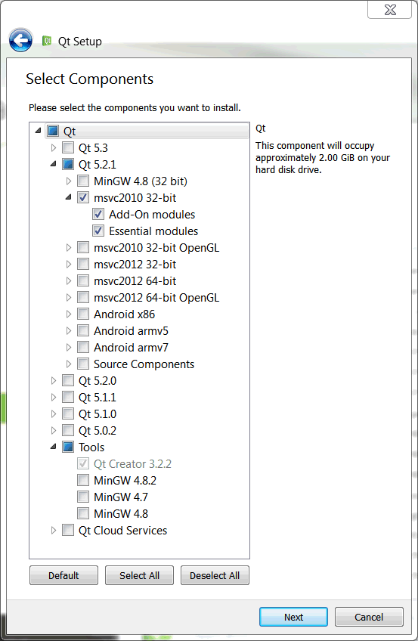

Next, run “RSA Create Installer.msi”. After installation completes, open Qt Creator and add the RSA Create Installer tool to it as follows:

Click Tools → External → Configure to access the tool configuration menu



Click the Add button, then select Add Category

Name this new category “Rohde-Schwarz”



With “Rohde-Schwarz” highlighted, once again click the Add button, then click Add Tool

Name the tool “Create Installer” and give it the following settings:

**Description:** “This tool creates an installer for an RsaToolbox application”

**Executable Path:** This is the location of the RSA Create Installer executable. The default location on a 64-bit machine is:

*C:\Program Files (x86)\Rohde-Schwarz\RSA Create Installer\RSA Create Installer.exe*

**Arguments:** Click the Arguments text edit field, then click the Variables icon on the right. Double-click “CurrentProject:BuildPath”, then close the window. The Arguments value should be “%{CurrentProject:BuildPath}”

**Working Directory:** Click the Variables icon and choose “CurrentProject:FilePath”, then append the text “/Installer” to the end. The Working directory value should be “%{CurrentProject:Path}\Installer”

Refer to the example RSA Create Installer setup shown below:

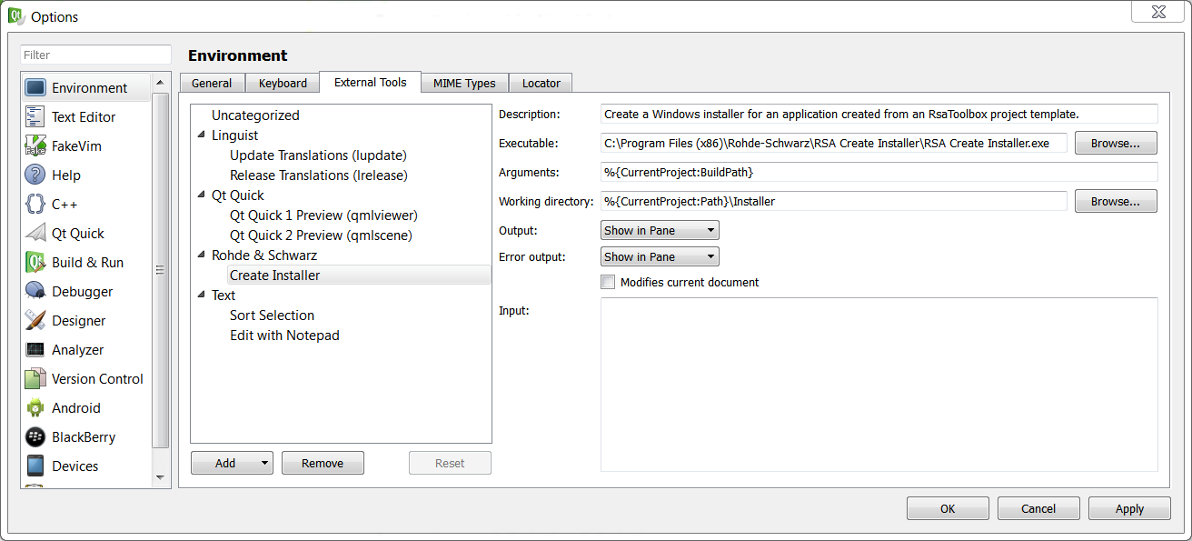

Click Ok to accept and save these changes

And finally, unpack and copy the contents of RsaToolbox Templates.zip to the Qt Creator project templates directory.

The default location is:

C:\Qt\Tools\QtCreator\share\qtcreator\templates\wizards

Restart Qt Creator for these changes to take effect. Click the New Project button and confirm that the RsaToolbox projects are installed.

